# Workaholic User Guide V1

16.03.2020

Jordan Harrison -

Contents

1 Introduction 1

1.1 Scope and Purpose 1

1.2 Pre-Requisites 1

2 Actions and Processes 3

2.1 Accessing Workaholic 3

2.2 Creating a Team 4

2.3 Changing a Team 7

2.4 Inviting Users to a Team 8

2.5 Creating a Task 10

2.6 Changing a Task 13

2.6 Complete a Task 15

3.1 Adding personalised skills 17

3.2 Show Invite Code 18

3.3 Scan QR code 19

3.5 Browse to QR Code image file 20

3.4 Adding level requirements 21

3.6 Accepting an Invite 23

## 1 Introduction

### 1.1 Scope and Purpose

Workaholic is a fully responsive web application designed to enable management of people with the goal of fostering engagement and encouraging organisational goals through gamification. The main element of gamification is Skill-Levels that a user can earn whilst going about their normal work day or as part of a personal organisation process. Experience gained through completing tasks aims to promote engagement with labour and documenting of task completion. Encouraging prioritisation of different tasks can be achieved by awarding more experience points to more important tasks.

This document is intended to give a user instruction on how to use the Workaholic app. In section 2 any major processes are discussed. Section 3 is used to discuss any sub processes that may be done as part of a major process.

### 1.2 Pre-Requisites

* Internet Capable Device
* Modern Internet Browser (Firefox, Safari, Google Chrome)
* Google Account

## 2 Actions and Processes

The following section discusses how a user would go about performing all the major actions on the application.

### 2.1 Accessing Workaholic

Using any of the following modern browser (Firefox, Safari, Google Chrome) type the following address into the URL field.

<https://workaholic-web.firebaseapp.com/>

On accessing the website, you will be prompted to log in through a google account Figure 1 and accept the cookie policy Figure 2.

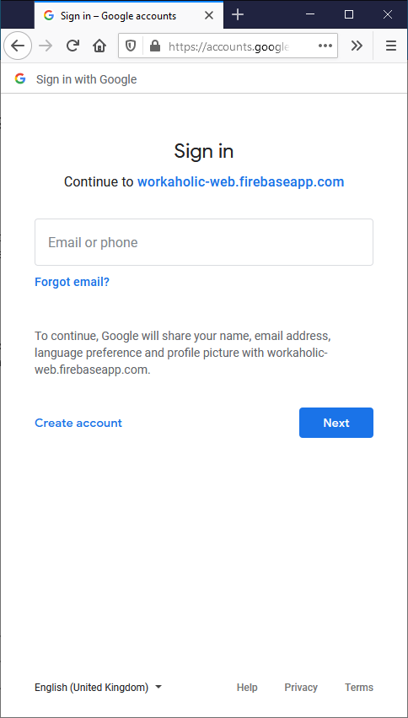

Figure 1 Login Screen

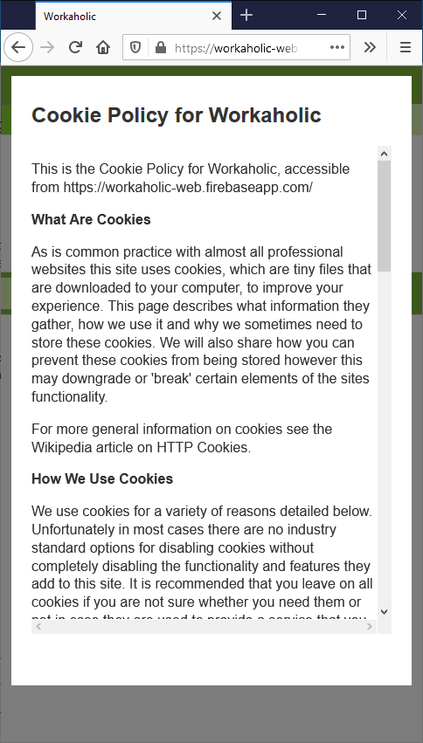

Figure 2 Cookie policy message

### 2.2 Creating a Team

Start by Creating or joining a team. Teams act as organisational units for tasks and giving you and other team members access. Membership of a team controls visibility and access to shared task data.

In order to create a team, do the following:

1. Navigate to the team page Figure 3

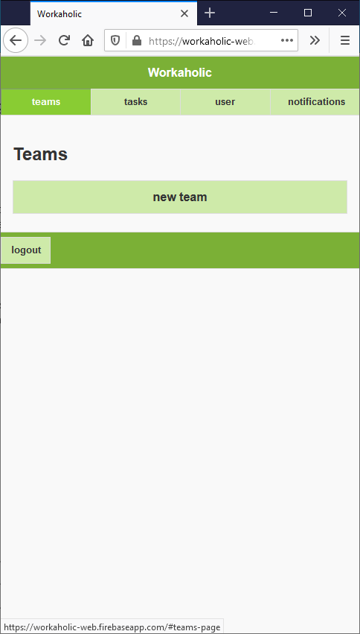

Figure 3 navigate to teams page

1. Press the new team button Figure 4



Figure 4 new team button

1. Enter information about the team in the form (Figure 5)

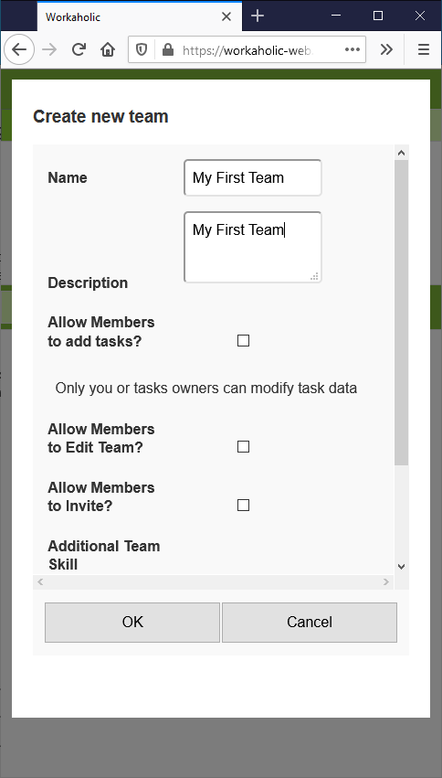

Figure 5 new team form

|  |  |
| --- | --- |
| Team Properties | |
| Name | Name of the team |
| Description | Description of the team |
| Allow members to add tasks? | If ticked allow any member of the team to add edit their own tasks. |
| Allow Members to Invite? | If ticked allow any member to add new members to the team. |
| Allow Members to edit teams | If ticked allow any member to modify team data |
| Personalised Skills | Allow users to Add new skills that can be allocated to tasks |

Figure 6 table of the team values a user can change and their meaning

1. Submit the form by pressing ok to create the team (Figure 5)
2. The new team can now be found in the teams page (Figure 7).

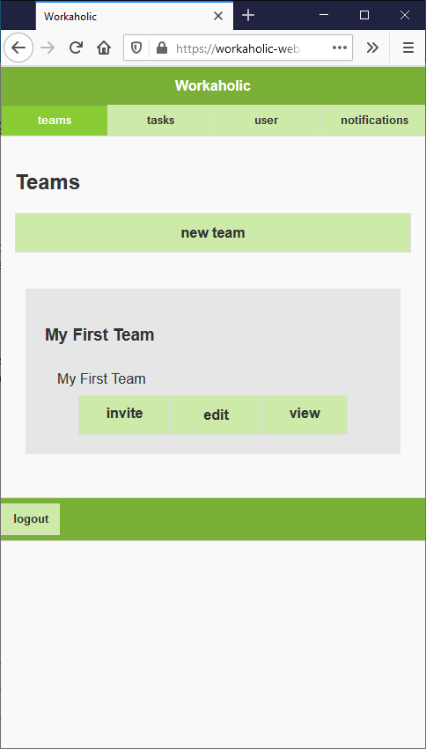

Figure 7 new team displayed on Teams page

### 2.3 Changing a Team

A user may wish to change properties of the team after creation, any changes made will update any device viewing the teams page. Changing team properties is performed through the following steps.

* 1. Navigate to team page (Figure 3).
  2. Press Edit button on the team (Figure 8).

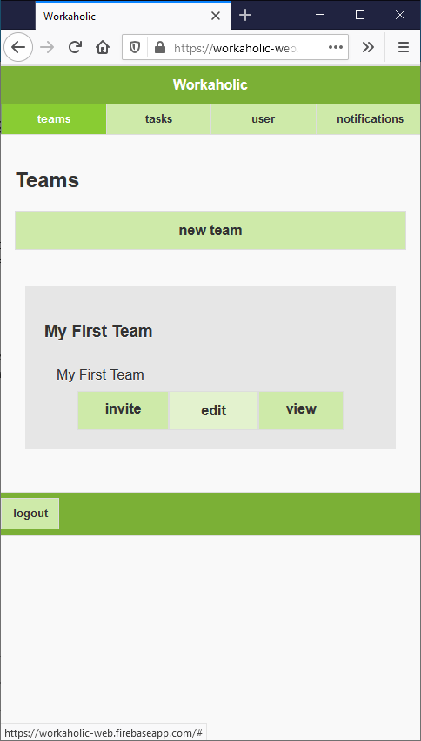

Figure 8 Team edit button

* 1. Change any of the information in the form (Figure 9).

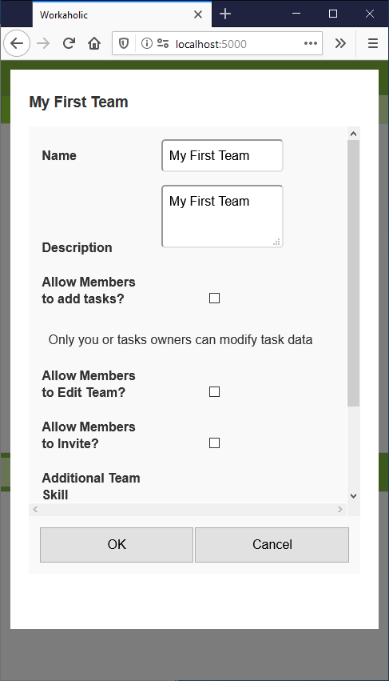

Figure 9 Change team form

* 1. Submit the changes by pressing ok (Figure 9).

### 2.4 Inviting Users to a Team

Task and team data can be shared amongst any number of users. A member of a team can complete any tasks set against that team. The team properties can be used to modify what other things team members are able to do.

Once a user has been invited to a team they must then accept the invite (3.6) to become a member of the team. A user’s membership to the team is currently not reversable in the interface.

* 1. Navigate to the Teams page (Figure 3).
  2. Press Invite on the desired team (Figure 10).

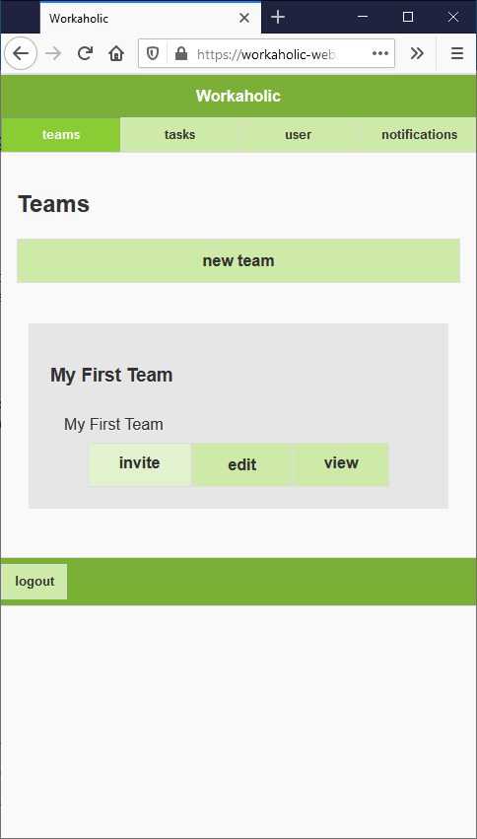

Figure 10 Invite to team button

This button will not be present on teams that a user doesn’t own that hasn’t allowed permission for other users to invite (2.2 c). Owners of teams will always be able to invite other users.

User codes are document reference codes that link to a user’s login. User codes can be input in the 3 following ways. The easiest way is on a mobile device by scanning a user’s QR Code (3.3) but they can also be added by inputting a code directly in the text box or by using an image file of the QR code (3.4).

* 1. Input user code (3.2)
     1. Scan a QR cod
     2. Type in the user code
     3. Browse to QR code image file
  2. Submit the form by pressing invite (Figure 11) Multiple users can be invited by repeating the process.

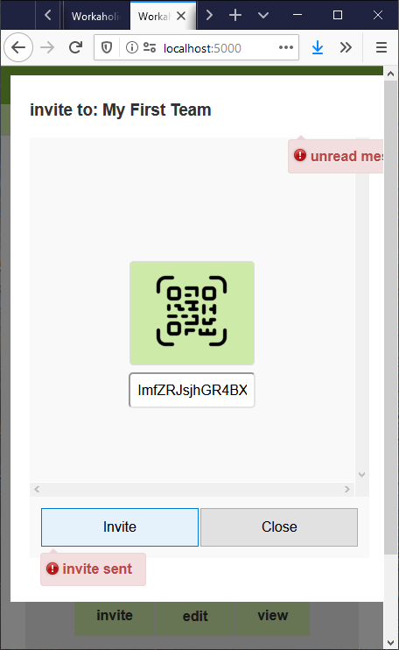

Figure 11 Invite sent

* 1. Close the form when finished (Figure 11).

### 2.5 Creating a Task

Tasks are the main way for teams to communicate and create an outlet for users to collaborate in team work. Level requirements help to promote optimum challenge. Users may seek to complete higher experience tasks to earn experience quicker, influencing volentary participation in team goals. Any member of a team can see and complete tasks, provided they have met the skill level requirments. Tasks can be created by doing the following:

1. Navigate to the Teams page Figure 3
2. Press view on the team to navigate to the teams tasks Figure 12

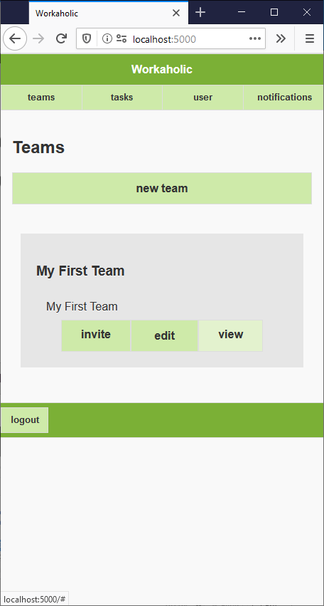

Figure 12 Team view button

1. Press the add task button (Figure 13). This button will not appear for members of a team that don’t have the setting enabled (3.3c)

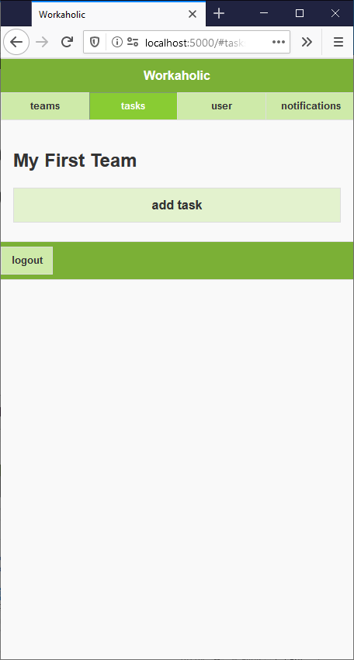

Figure 13 add tasks button on tasks page

1. Enter in Task information into the form that displays (Figure 14).

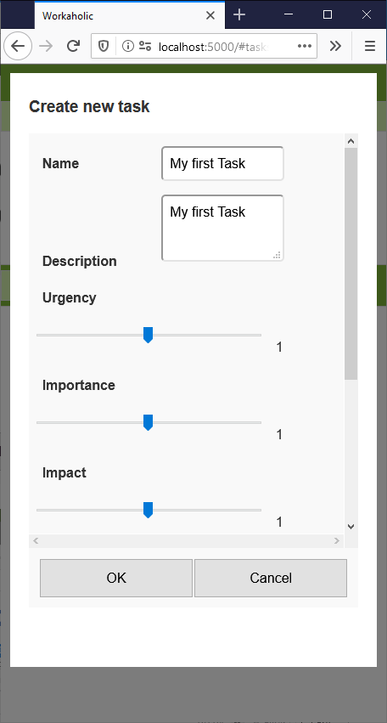

Figure 14 New Task form

|  |  |
| --- | --- |
| **Task properties** | |
| Name | The name of the task |
| Description | The description of the task |
| Urgency | How urgent the task is from 0 (least) to 2 (most). Applies a factor to the experience rewards. |
| Importance | How important the task is from 0 (least) to 2 (most). Applies a factor to the experience rewards. |
| Impact | The impact of completing the task is from 0 (least) to 2 (most). Applies a factor to the experience rewards. |
| Level Requirements (3.4) | The levels required in order to complete the task. This will prevent any team member from being able to complete the task without meeting the requirements. Sets which type of skill experience this task awards. |
| Deadline | The date the task needs to be finished. |

Figure 15 properties of tasks and the relevance

1. Submit the form by pressing ok Figure 14

### 2.6 Changing a Task

A user may wish to change properties of the task after creation, any properties changed will update on any device viewing the task list. Changing tasks information is done through the following steps:

1. Navigate to team page (Figure 3)
2. Press view on the team to navigate to the team’s tasks (Figure 11)

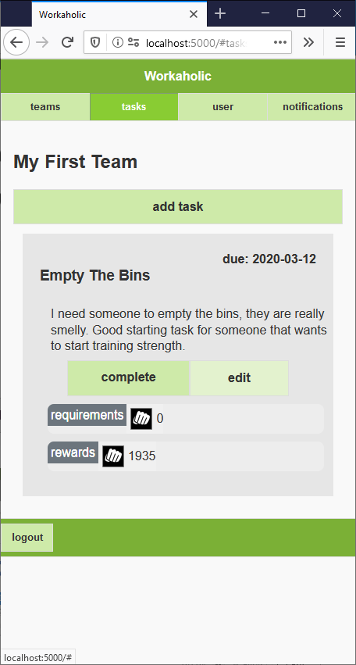

Figure 16 Team edit button

1. Change any of the information in the form Figure 17

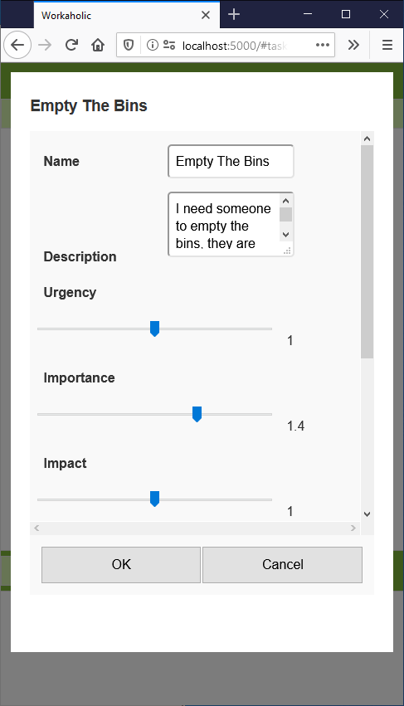

Figure 17 change task form

d. Click ok (Figure 17) on the form after making changes to commit them

### 2.7 Complete a Task

Completing tasks is how a user can earn experience in skills. At this point the user should have already finished the labour defined by the task after they have identified whether or not they have the pre-requisites. The task con then be completed in the following way:

1. Navigate to the Teams Page (Figure 3).
2. Press view (Figure 12) on the team to display the teams Tasks (Figure 18).
3. Press complete on the task card (Figure 18).

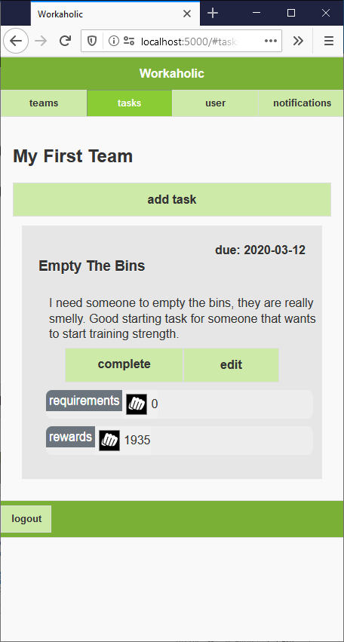

Figure 18 Team Task list

1. Completing a task. There are two potential actions that occur when pressing the complete button.
2. If the task is successfully complete it will be removed from the list and the task completer will be awarded experience. In (Figure 19) level has increased and is displayed.

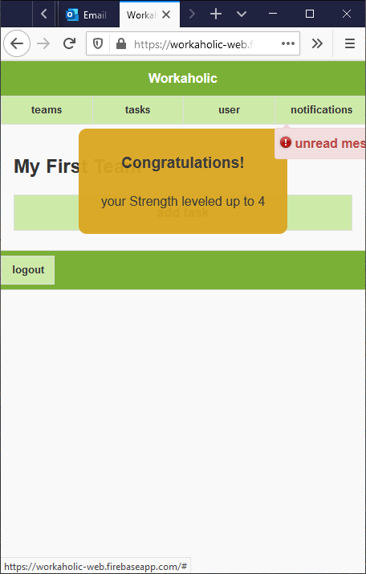

Figure 19 Level up fanfare

1. . If the user does not have enough levels in the specific skill to complete the task a message with be displayed to show them that is the case (Figure 20).

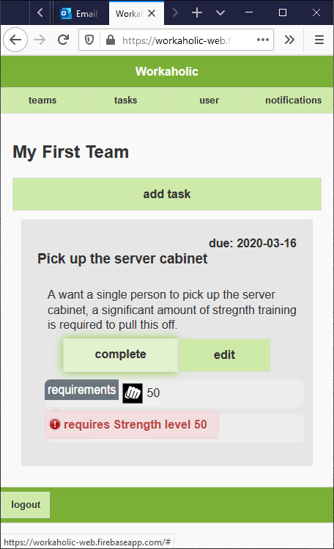

Figure 20 Skill level requirement not met

# 3 Sub-Processes

## 3.1 Adding personalised skills

This is relevant during the creating (2.2) or changing (2.3) of a team. Different teams can award experience in the same custom skill. Renaming skills will not change the name of a team members skill level but will instead create a new skill on the team with the defined name.

* 1. Press the add skills button Figure 21

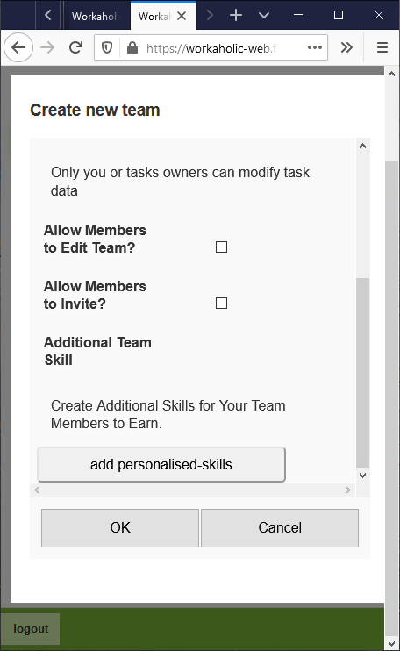

Figure 21 Add skills button

* 1. Type in a name for the skill (Figure 22). Skills can be removed from a team by pressing the x next to the skill name.

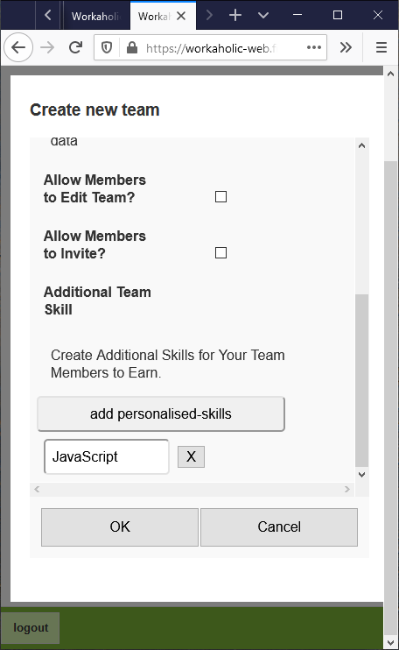

Figure 22 Skill Name Entree

## 3.2 Show Invite Code

This process is part of the invite process. A user can do this to present their code for them to be invited to a new Team (2.4).

1. Navigate to user page Figure 23

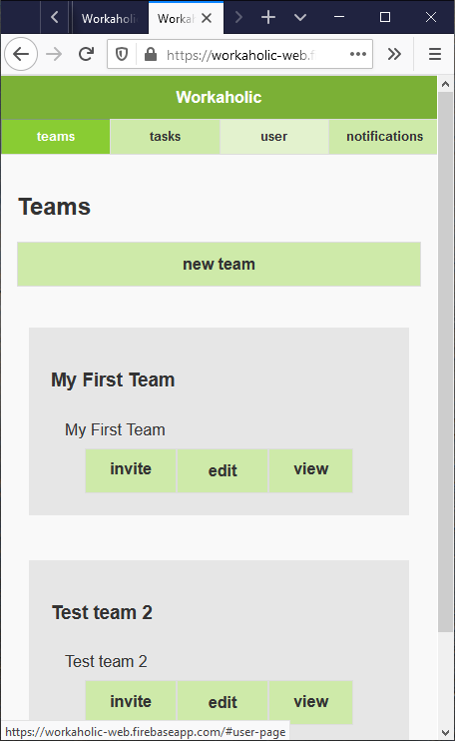

Figure 23 Navigate to user page

1. Press user code button to show the logged in users code (Figure 24).

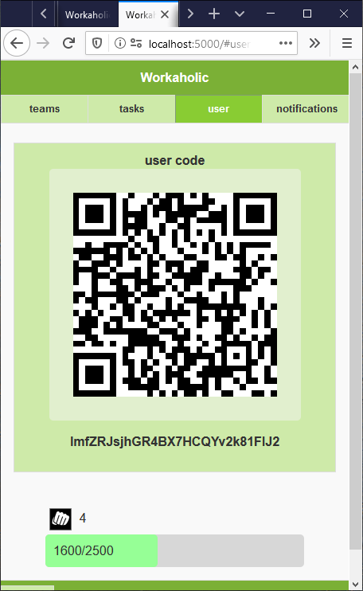

Figure 24- User QR code

## 3.3 Scan QR code

This sub-process is done as part of the invitation process (2.4). This process assumes the application is running on a mobile device.

1. Press the scan QR code button (Figure 25). Scanning can also be done by using an external QR reading application and copying the text found into the input box.

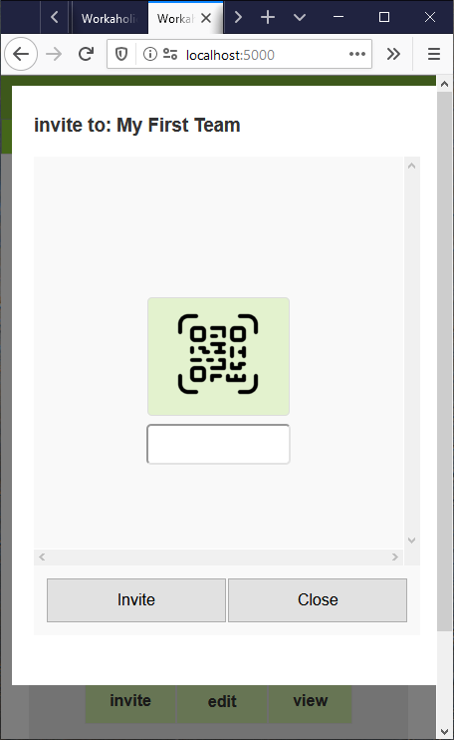

Figure 25 Scan code button

1. Pressing this button on a mobile app will launch the camera application. Take a picture of a user’s invite code.
2. Submit Invite will show that an invite was created Figure 11.

## 3.5 Browse to QR Code image file

This sub-process is done as part of the invitation process (2.4). This process assumes the application is open on a personal computer. It is suggested you use the sub-process (3.3) instead.

1. Press the scan QR code button (Figure 25).
2. Navigate to a file containing user QR data (Figure 26) and open the file. This dialogue may vary depending on operating system/browser.
3. 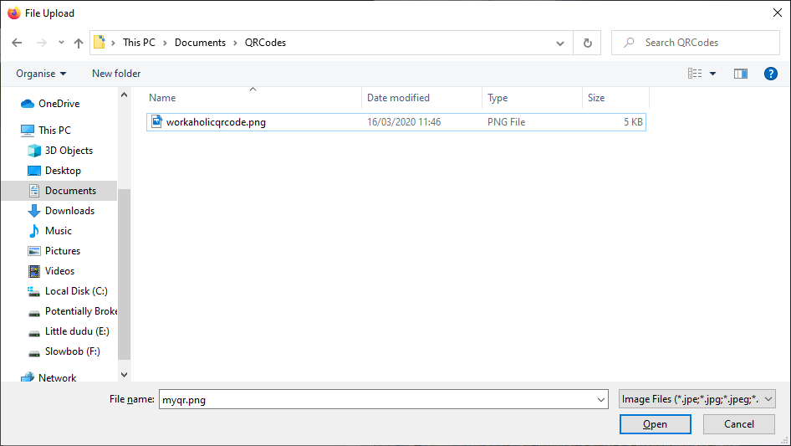

Figure 26 Browse to file

1. Submit Invite will show that an invite was create

## 3.4 Adding level requirements

Level requirements of tasks can be modified at any time, provided the user has appropriate permissions. Requirements can be changed whilst creating (2.5) or editing (2.6) a task Level requirements form the basis for the skills that a task award. Experience can be added to a task by adding a requirement for that skill, any requirements of level 0 will not stop a user completing a task, allowing initial levels in a skill to be gained. The following steps show how level requirement can be added to a task:

1. Press the add requirements button on the task form Figure 27.

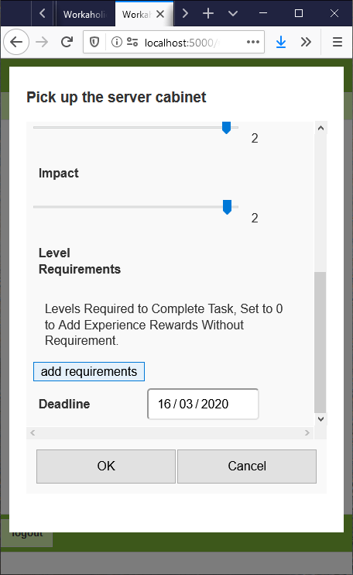

Figure 27 Add requirements button

1. Chose the type of skill added and the level required. Any requirements no longer needed can be removed by pressing the X button. Figure 28. Any duplicate skills here will overwrite subsequent ones.

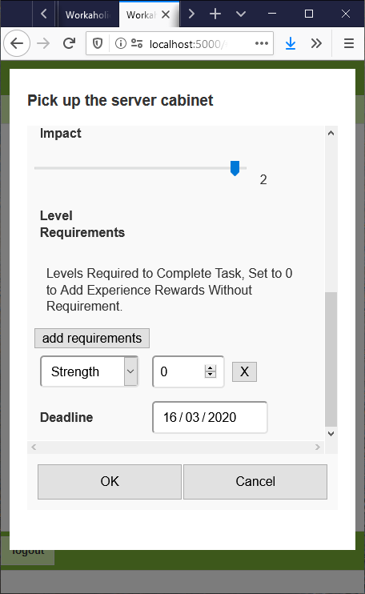

Figure 28 Task form with a requirement

## 3.6 Accepting an Invite

1. Navigate to notification page Figure 27.

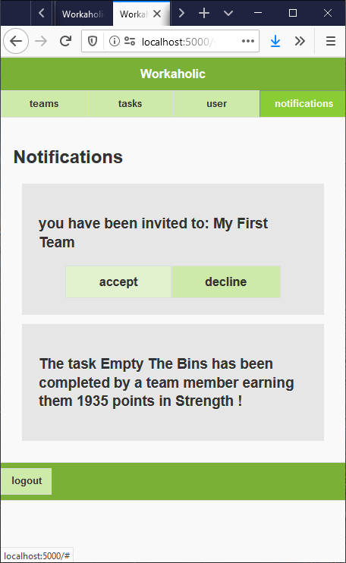

Figure 29 navigate to notifications page

1. Press accept on the invite notification Figure 28



Figure 30 accept invite button